Diabetes Prediction Using Machine Learning and Explainable Artificial Intelligence
Author Name
Department of Computer Science
Institution Name, City, Country
Abstract
Diabetes is one of the most widespread chronic diseases worldwide, posing serious threats to human health due to its long-term complications. Early prediction and diagnosis can significantly improve patient outcomes. This study presents a comparative analysis of multiple Machine Learning (ML) and Deep Learning (DL) models for diabetes prediction using the Pima Indians Diabetes Dataset. Six models were implemented: Logistic Regression, Decision Tree, Random Forest, Support Vector Machine (SVM), K-Nearest Neighbors (KNN), and Artificial Neural Network (ANN). The dataset was preprocessed through missing value handling, feature scaling, and exploratory data analysis. Hyperparameter tuning and cross-validation were applied to improve model performance. Models were evaluated using Accuracy, Precision, Recall, F1-score, and ROC-AUC metrics. Explainable Artificial Intelligence (XAI) was integrated using SHAP (SHapley Additive Explanations) to provide transparency and interpretability. Experimental results demonstrated that the ANN achieved the highest ROC-AUC score of 82.04%, while Random Forest produced the highest accuracy of 77.92%. SHAP analysis identified Glucose, BMI, and Age as the most influential factors affecting diabetes prediction.

Keywords—Diabetes Prediction, Machine Learning, Artificial Intelligence, Explainable AI, SHAP, ANN, Random Forest, Healthcare Analytics

I. INTRODUCTION
Diabetes is a chronic metabolic disease characterized by elevated blood glucose levels caused by insufficient insulin production or ineffective insulin utilization within the body. According to global healthcare statistics, diabetes has become one of the leading causes of mortality and severe long-term health complications, including cardiovascular diseases, kidney failure, nerve damage, and vision impairment [1].
Early diagnosis and prediction of diabetes are essential for preventing complications and improving healthcare outcomes. In recent years, Machine Learning (ML) and Artificial Intelligence (AI) techniques have emerged as powerful tools for predictive healthcare analytics. These technologies can analyze large medical datasets efficiently and identify hidden relationships among patient features to assist healthcare professionals in disease diagnosis and decision-making [2].
Several Machine Learning algorithms such as Logistic Regression, Decision Trees, Support Vector Machines, Random Forests, and Neural Networks have been widely applied in healthcare prediction systems. However, many predictive systems still face challenges regarding transparency and interpretability. In healthcare environments, it is critical not only to achieve high predictive accuracy but also to explain the reasoning behind model predictions [3].
To address this challenge, Explainable Artificial Intelligence (XAI) techniques such as SHAP (SHapley Additive Explanations) have been introduced to improve interpretability and trust in predictive systems. SHAP explains how individual features contribute toward the final prediction, making Machine Learning systems more transparent and reliable for healthcare applications [4].
This research develops a comprehensive diabetes prediction system using multiple ML and Deep Learning models combined with SHAP explainability. The contributions of this paper are: (1) comparative analysis of six ML/DL models on the Pima Indians Diabetes Dataset; (2) rigorous evaluation using five performance metrics including ROC-AUC; (3) hyperparameter tuning via GridSearchCV and 5-fold cross-validation; and (4) SHAP-based explainability analysis identifying the most influential clinical features.
II. LITERATURE REVIEW
Machine Learning techniques have gained significant importance in healthcare predictive analytics over the past decade. Several studies have demonstrated the effectiveness of AI-driven systems for predicting chronic diseases such as diabetes, heart disease, and cancer [5].
Logistic Regression has traditionally been used as a baseline classification model because of its simplicity and interpretability. However, its performance is often limited in handling nonlinear relationships among medical features. Decision Tree algorithms provide interpretable classification structures and can effectively model nonlinear relationships, yet individual decision trees may suffer from overfitting [6].
To overcome these limitations, ensemble methods such as Random Forest were developed. Random Forest combines multiple decision trees using bagging to improve generalization and predictive accuracy. Studies have consistently demonstrated Random Forest achieving superior performance in diabetes classification tasks [7].
Support Vector Machines are powerful classification algorithms capable of handling high-dimensional feature spaces and complex decision boundaries. K-Nearest Neighbors is another commonly used method based on similarity and distance metrics, effective for moderate-sized datasets [8].
Artificial Neural Networks have shown exceptional capability in learning complex nonlinear patterns and relationships within healthcare datasets. Deep learning models are increasingly being applied in predictive healthcare systems because of their strong adaptability and learning capability [9].
Recently, Explainable Artificial Intelligence techniques have become highly important in medical applications. SHAP provides both local and global interpretability by calculating Shapley values derived from cooperative game theory. This approach improves transparency and trust in AI-based healthcare systems, enabling clinicians to understand and validate model decisions [10].
III. DATASET DESCRIPTION
A. Dataset Characteristics
This study utilizes the Pima Indians Diabetes Dataset obtained from the UCI Machine Learning Repository via Kaggle. The dataset contains medical diagnostic measurements collected from female patients of Pima Indian heritage, aged 21 years and older. Table I presents the dataset characteristics.

TABLE I
Dataset Characteristics
Attribute | Description
Total Samples | 768
Input Features | 8
Target Variable | Outcome (0 or 1)
Classification Type | Binary Classification

B. Dataset Features
Table II describes the eight input features and the binary target variable used for diabetes classification.

TABLE II
Dataset Features Description
Feature | Description
Pregnancies | Number of times pregnant
Glucose | Plasma glucose concentration
BloodPressure | Diastolic blood pressure (mm Hg)
SkinThickness | Triceps skin fold thickness (mm)
Insulin | 2-Hour serum insulin (mu U/ml)
BMI | Body Mass Index (kg/m²)
DiabetesPedigreeFunction | Diabetes hereditary function
Age | Age of patient (years)
Outcome | Diabetes status (0 = No, 1 = Yes)

The dataset initially contained several unrealistic zero values in medical attributes such as Glucose, BloodPressure, SkinThickness, Insulin, and BMI. These values were treated as missing measurements and replaced using median imputation techniques during preprocessing.
IV. PROPOSED METHODOLOGY
The proposed diabetes prediction system follows a structured pipeline comprising ten stages: (1) Dataset Collection, (2) Data Preprocessing, (3) Exploratory Data Analysis, (4) Feature Scaling, (5) Train-Test Split, (6) Model Training, (7) Hyperparameter Tuning, (8) Model Evaluation, (9) SHAP Explainability Analysis, and (10) Comparative Performance Analysis.
A. Data Preprocessing
Invalid zero values in Glucose, BloodPressure, SkinThickness, Insulin, and BMI columns were replaced using column-wise median imputation. Feature scaling was applied using StandardScaler from scikit-learn to normalize all feature distributions, ensuring zero mean and unit variance. The dataset was divided into 80% training (614 samples) and 20% testing (154 samples) subsets with a fixed random state for reproducibility.
B. Exploratory Data Analysis
Exploratory Data Analysis was performed to understand feature distributions, identify correlations, and visualize relationships. Fig. 1 shows the class distribution of the dataset.

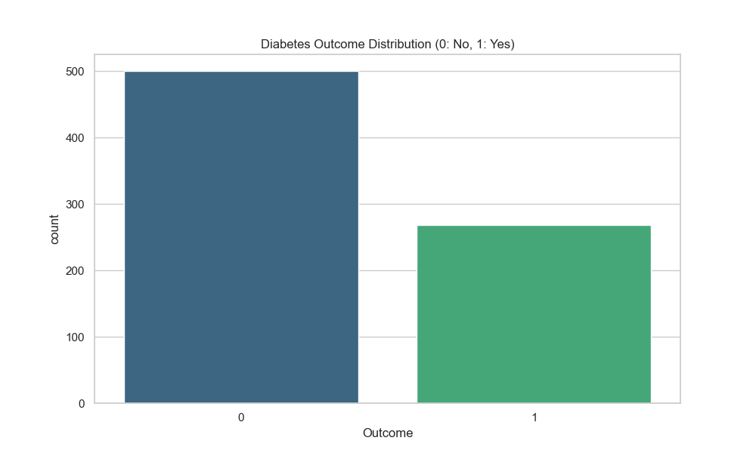
Fig. 1. Class Distribution of the Pima Indians Diabetes Dataset.
A correlation heatmap was generated to analyze relationships among features (Fig. 2). Glucose, BMI, and Age demonstrated stronger correlations with the diabetes outcome variable.

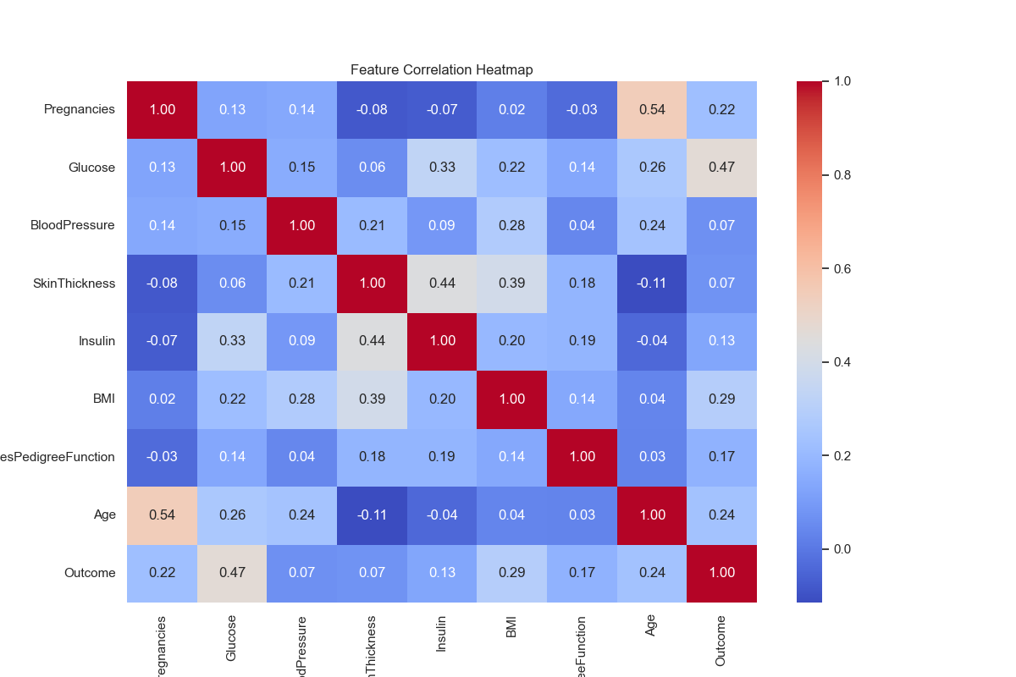
Fig. 2. Feature Correlation Heatmap.
Feature distributions were analyzed through histograms and boxplots, as shown in Figs. 3 and 4, to identify skewness patterns and outliers across medical attributes.

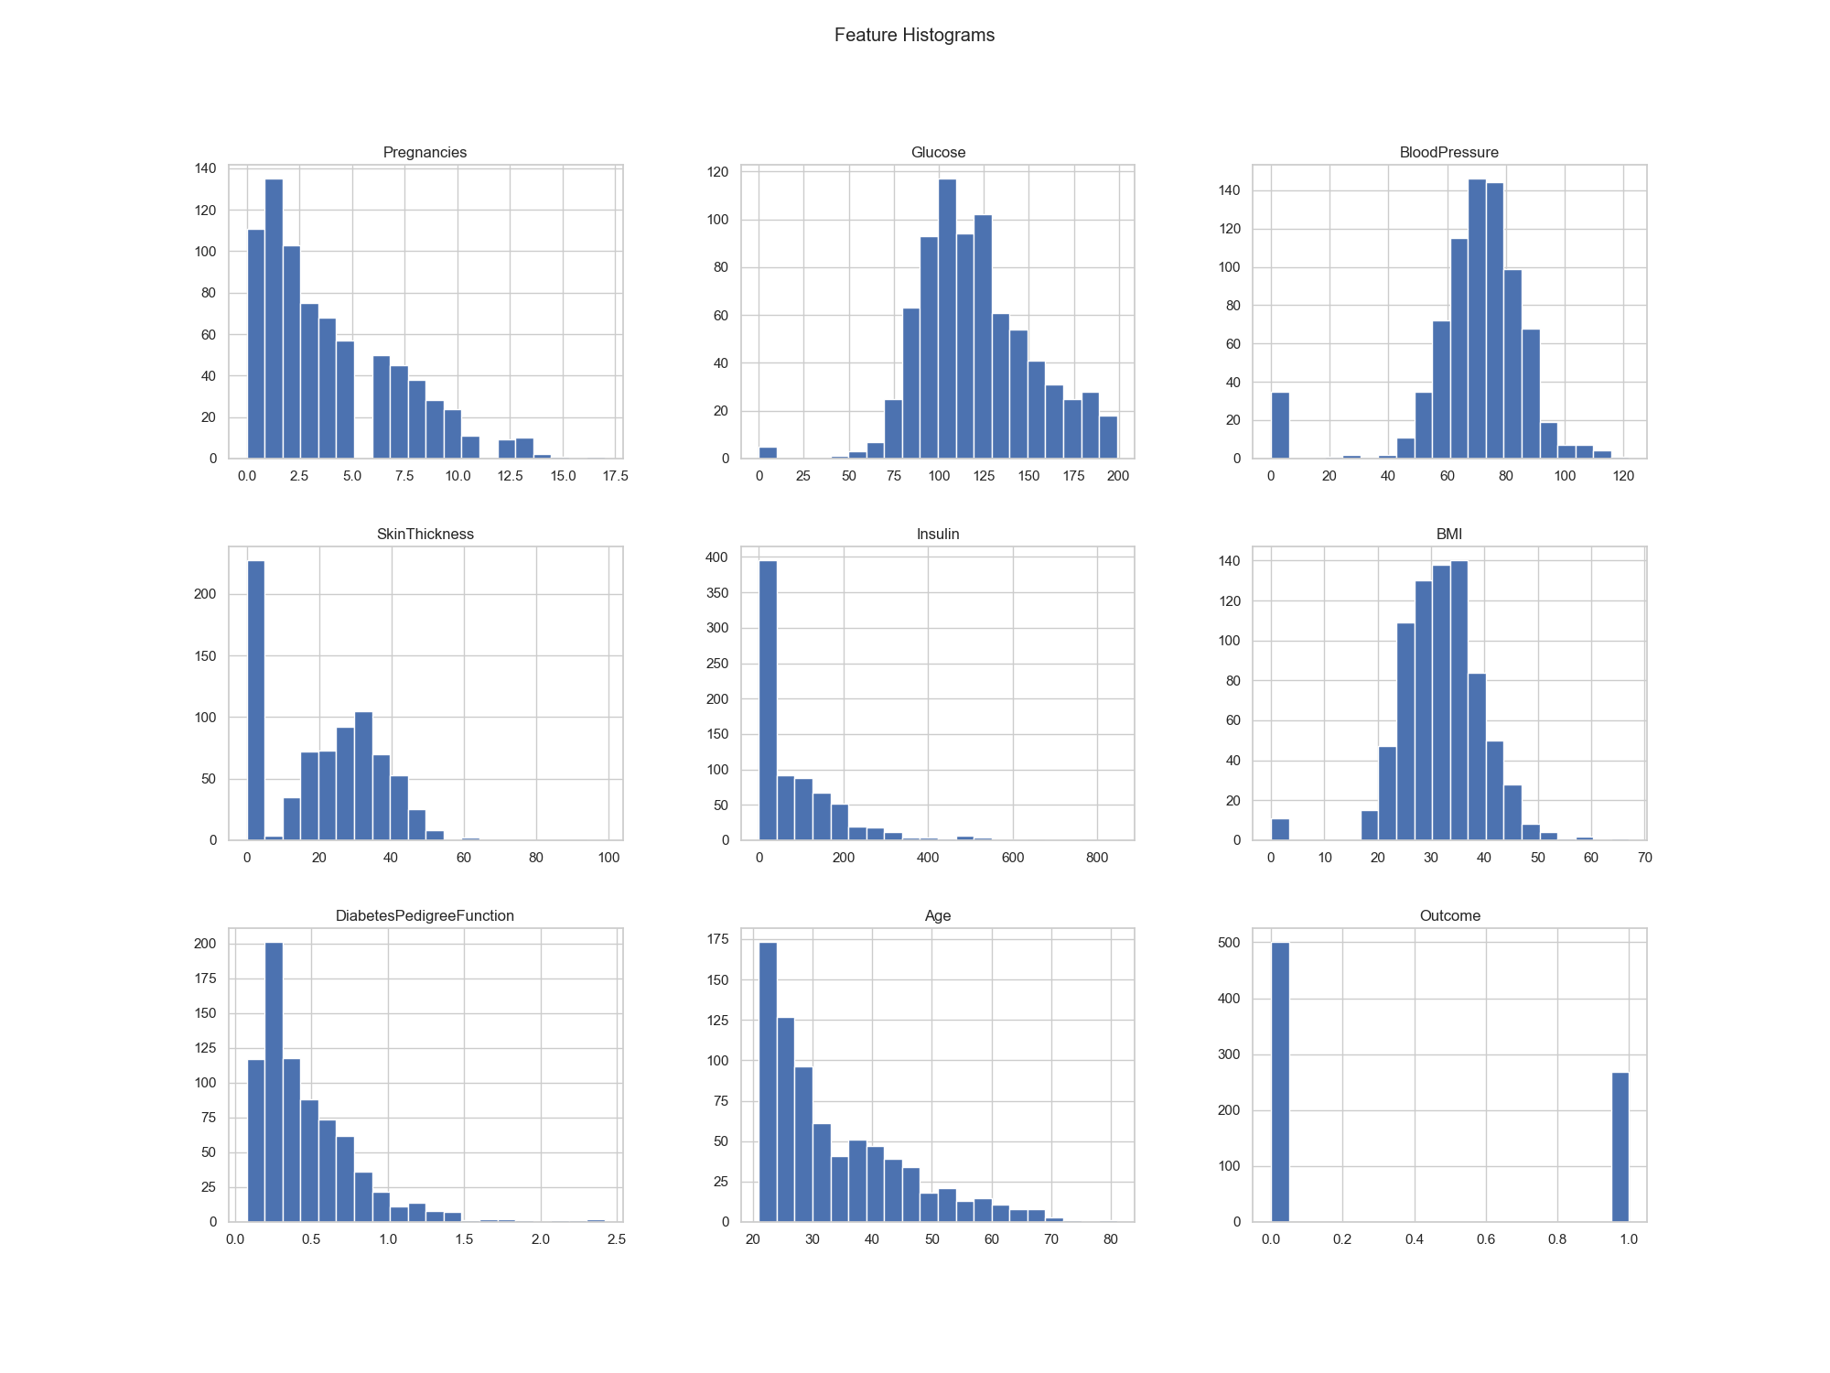
Fig. 3. Feature Distribution Histograms.

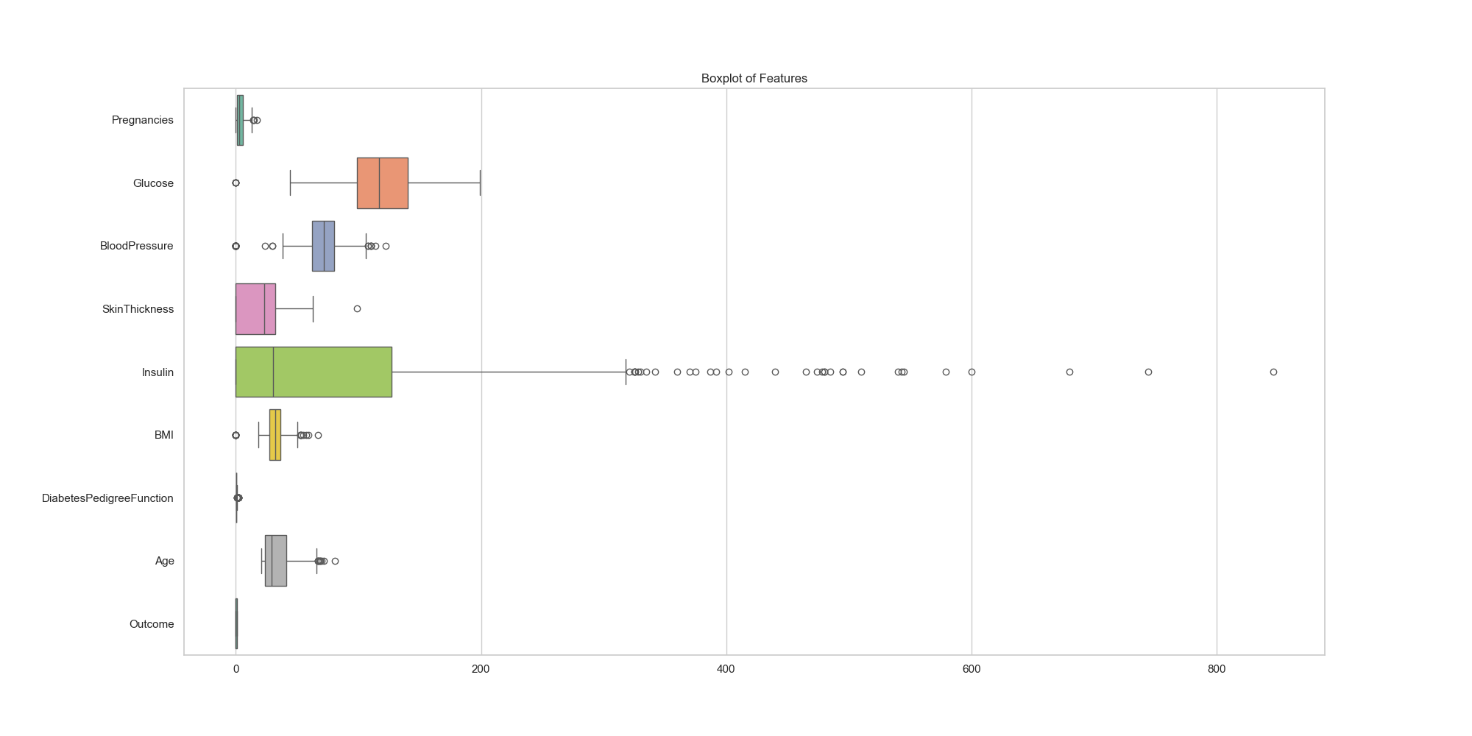
Fig. 4. Feature Boxplots Showing Outliers.
V. MACHINE LEARNING MODELS
A. Logistic Regression
Logistic Regression served as the baseline linear classification model. It models the probability of a binary outcome using a sigmoid activation function applied to a linear combination of input features.
B. Decision Tree
Decision Tree classification constructs hierarchical rules using recursive feature-based splits that minimize impurity (Gini index). It provides highly interpretable decision boundaries.
C. Random Forest
Random Forest employs bagging by training an ensemble of decision trees on bootstrapped subsets of training data. Predictions are aggregated through majority voting, which improves generalization and reduces overfitting.
D. Support Vector Machine
SVM identifies the optimal hyperplane maximizing the margin between class boundaries in the transformed feature space. A linear kernel was selected through GridSearchCV hyperparameter tuning.
E. K-Nearest Neighbors
KNN predicts class labels based on the majority class among the k-nearest training samples, measured using Euclidean distance. The optimal k=11 was determined through cross-validated tuning.
F. Artificial Neural Network
The ANN architecture comprised fully connected dense layers with ReLU activation in hidden layers and Sigmoid activation at the output layer for binary classification. Training configuration: Optimizer=Adam, Loss=Binary Crossentropy, Epochs=50, Batch Size=16. Fig. 5 shows the training history.

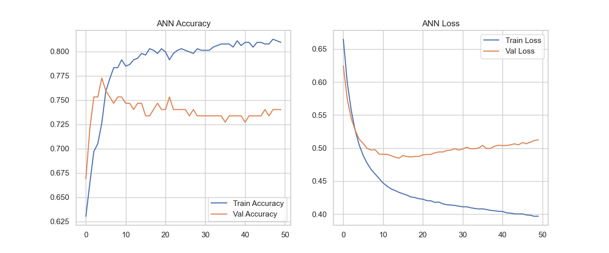
Fig. 5. ANN Training and Validation History (Accuracy and Loss).
VI. HYPERPARAMETER TUNING
Hyperparameter optimization was performed using GridSearchCV with 5-fold cross-validation for Random Forest, SVM, and KNN. The best hyperparameters identified are presented in Table III.

TABLE III
Optimal Hyperparameters
Model | Best Parameters
Random Forest | n_estimators=100, max_depth=None
SVM | C=0.1, kernel=linear
KNN | n_neighbors=11

Additionally, 5-fold cross-validation was applied to all models to assess generalization performance and reduce overfitting. Cross-validation accuracy scores are reported alongside test set metrics.
VII. EVALUATION METRICS
Model performance was assessed using five standard classification metrics: Accuracy (proportion of correctly classified instances), Precision (positive predictive value), Recall/Sensitivity (true positive rate), F1-Score (harmonic mean of Precision and Recall), and ROC-AUC (area under the Receiver Operating Characteristic curve). ROC-AUC is particularly informative for imbalanced datasets as it measures the model's discriminative ability independently of classification threshold.
VIII. EXPERIMENTAL RESULTS
Table IV presents the comprehensive performance comparison across all six models, including cross-validation accuracy.

TABLE IV
Comprehensive Model Performance Comparison
Model | Acc | Prec | Recall | F1 | AUC | CV Acc
Log. Reg. | 70.13% | 58.70% | 50.00% | 54.00% | 81.28% | 77.22%
Dec. Tree | 68.18% | 55.32% | 48.15% | 51.49% | 63.57% | 70.98%
Rnd. Forest | 77.92% | 72.73% | 59.26% | 65.31% | 81.91% | 76.44%
SVM | 70.78% | 60.47% | 48.15% | 53.61% | 81.30% | 76.56%
KNN | 73.38% | 63.27% | 57.41% | 60.19% | 79.19% | 75.79%
ANN | 74.03% | 64.58% | 57.41% | 60.78% | 82.04% | N/A

The ANN achieved the highest ROC-AUC score of 82.04% while Random Forest attained the best accuracy of 77.92%. The Decision Tree showed the lowest performance across most metrics due to overfitting tendencies. Logistic Regression and SVM demonstrated competitive ROC-AUC scores despite their linear nature.
A. ROC Curve Comparison
Fig. 6 illustrates the ROC curves for all six models. The ANN and Random Forest curves closely approximate each other near the top-left corner, confirming their superior discriminative ability.

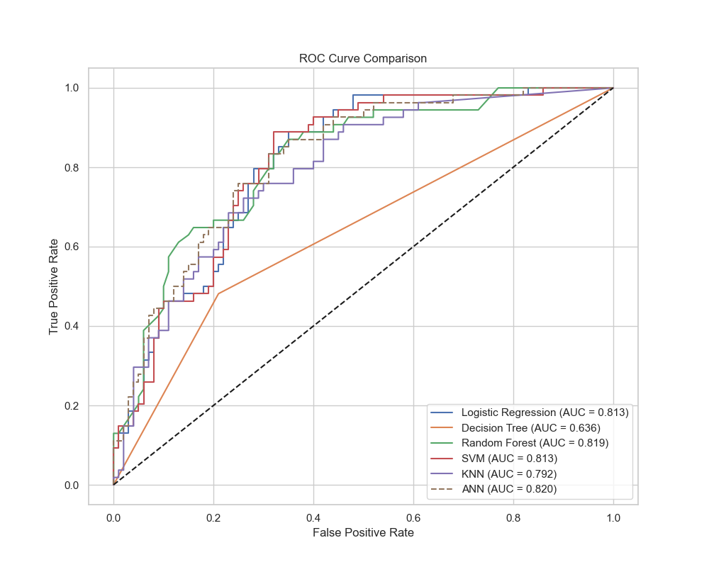
Fig. 6. ROC Curve Comparison Across All Models.
B. Comparative Metric Charts
Figs. 7-11 present bar chart comparisons for each evaluation metric across all models.

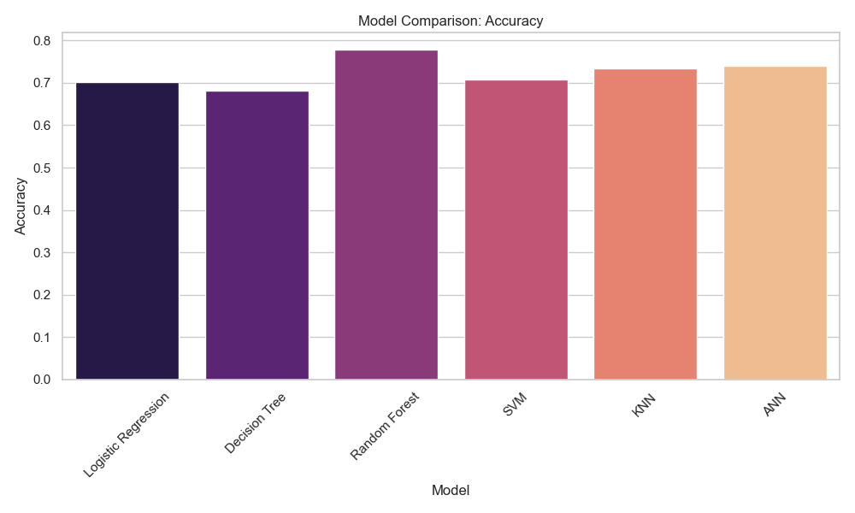
Fig. 7. Accuracy Comparison Across Models.

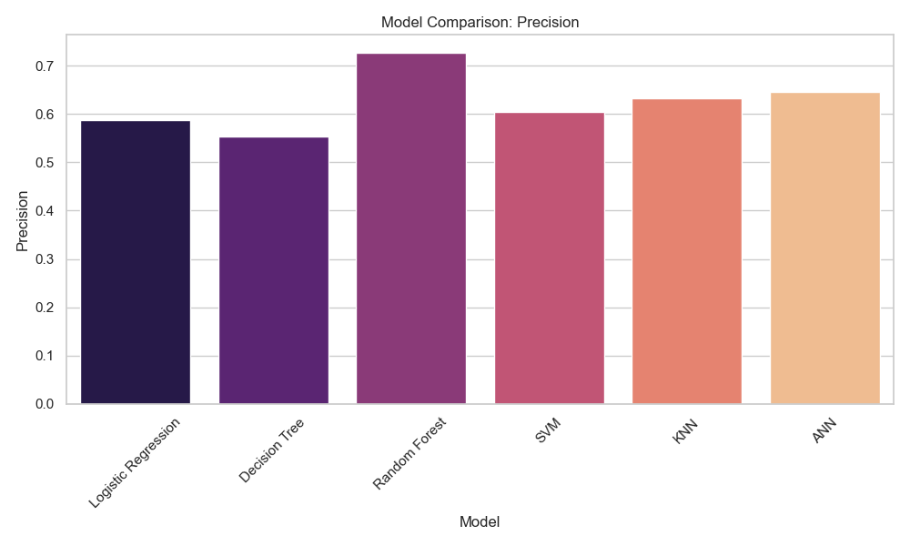
Fig. 8. Precision Comparison Across Models.

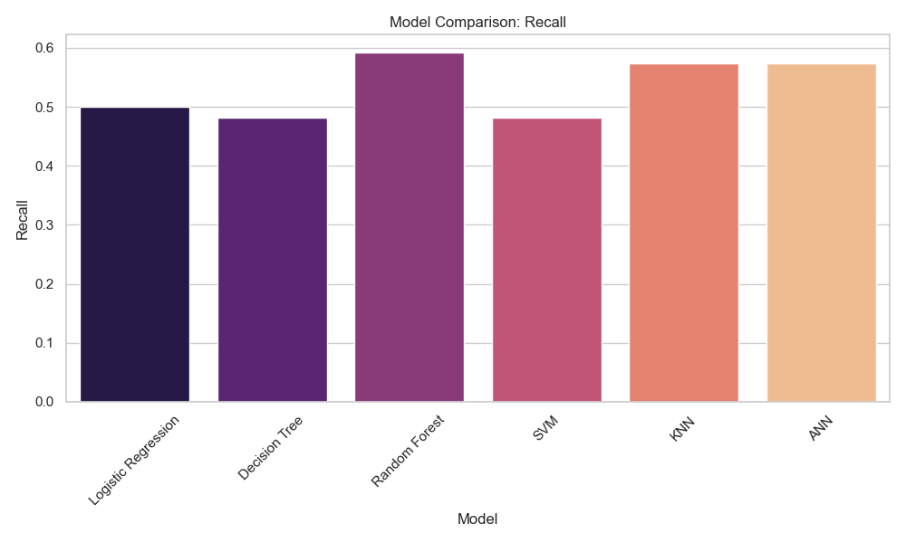
Fig. 9. Recall Comparison Across Models.

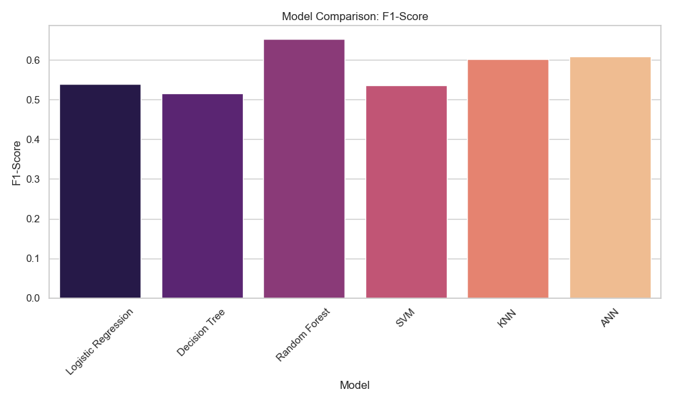
Fig. 10. F1-Score Comparison Across Models.

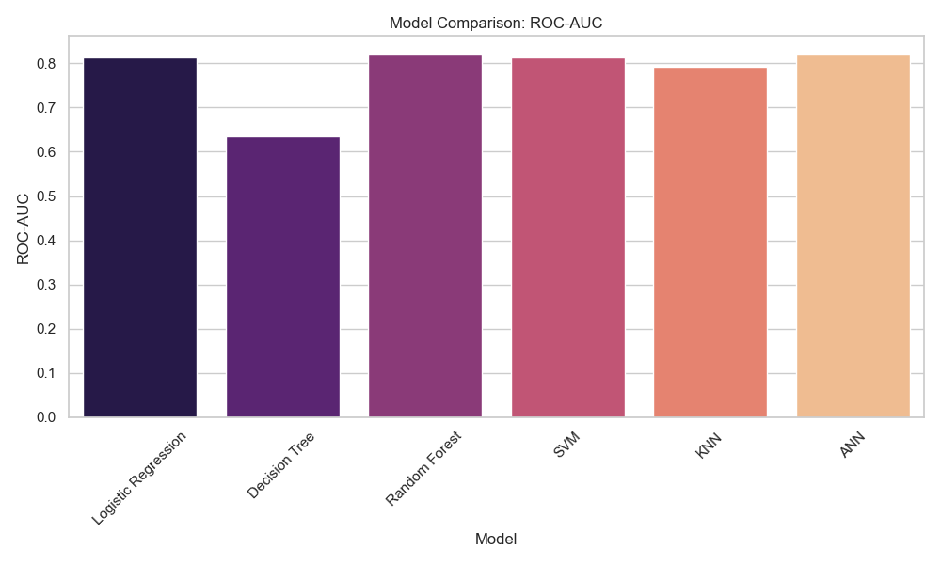
Fig. 11. ROC-AUC Comparison Across Models.
C. Confusion Matrices
Figs. 12-17 present confusion matrices for each model, showing the distribution of true positives, true negatives, false positives, and false negatives on the 154-sample test set.

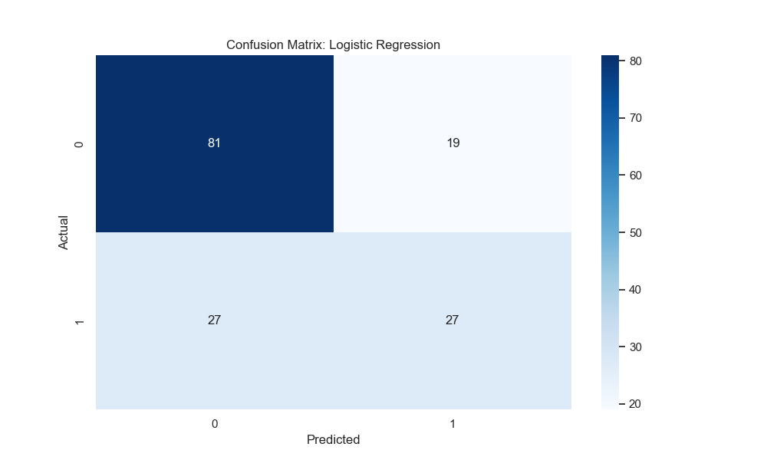
Fig. 12. Confusion Matrix - Logistic Regression.

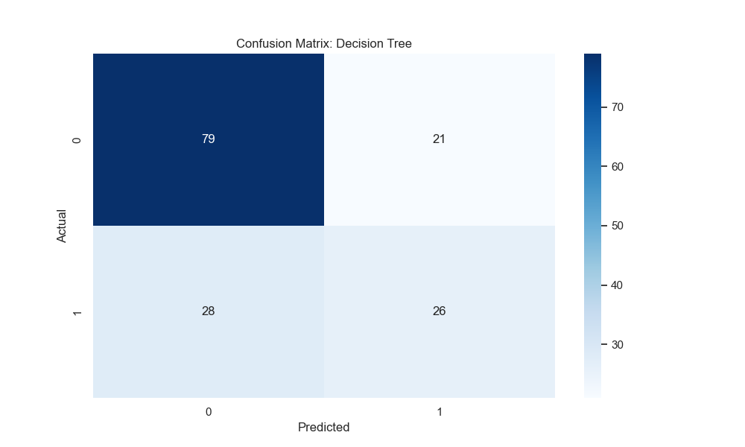
Fig. 13. Confusion Matrix - Decision Tree.

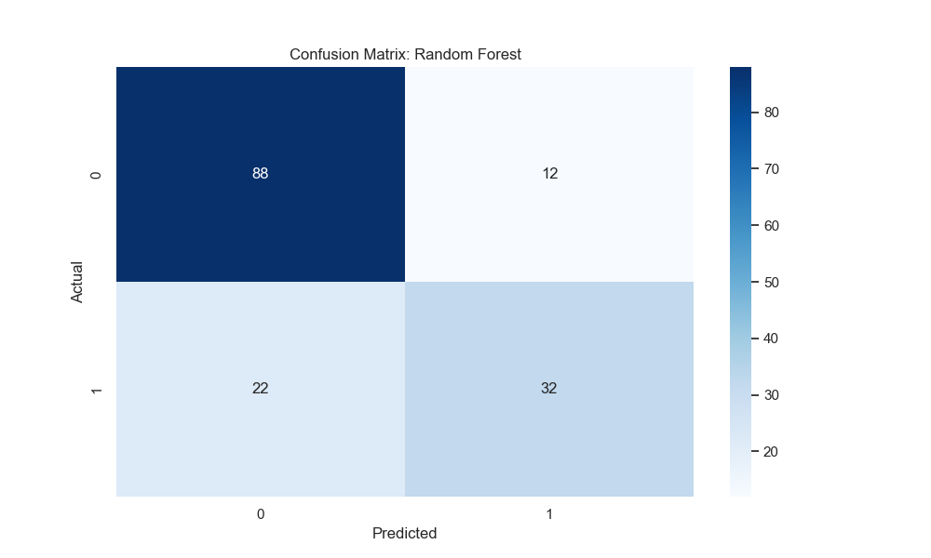
Fig. 14. Confusion Matrix - Random Forest.

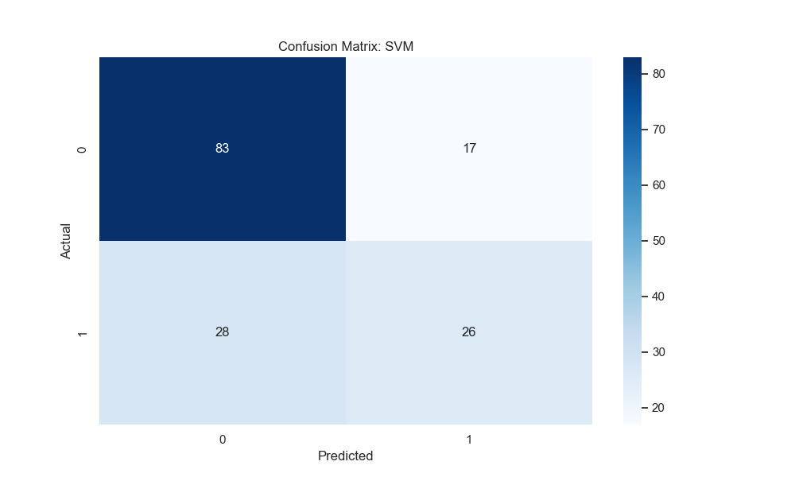
Fig. 15. Confusion Matrix - Support Vector Machine.

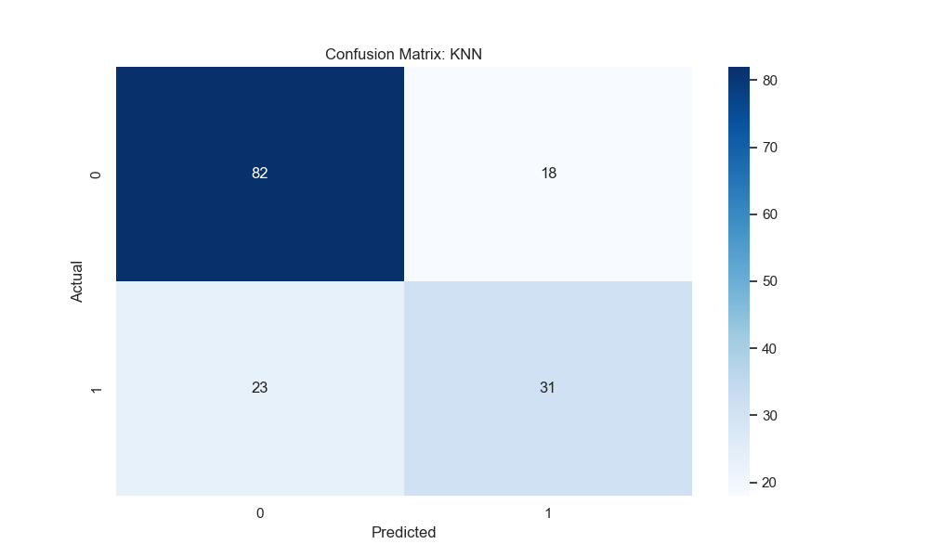
Fig. 16. Confusion Matrix - K-Nearest Neighbors.

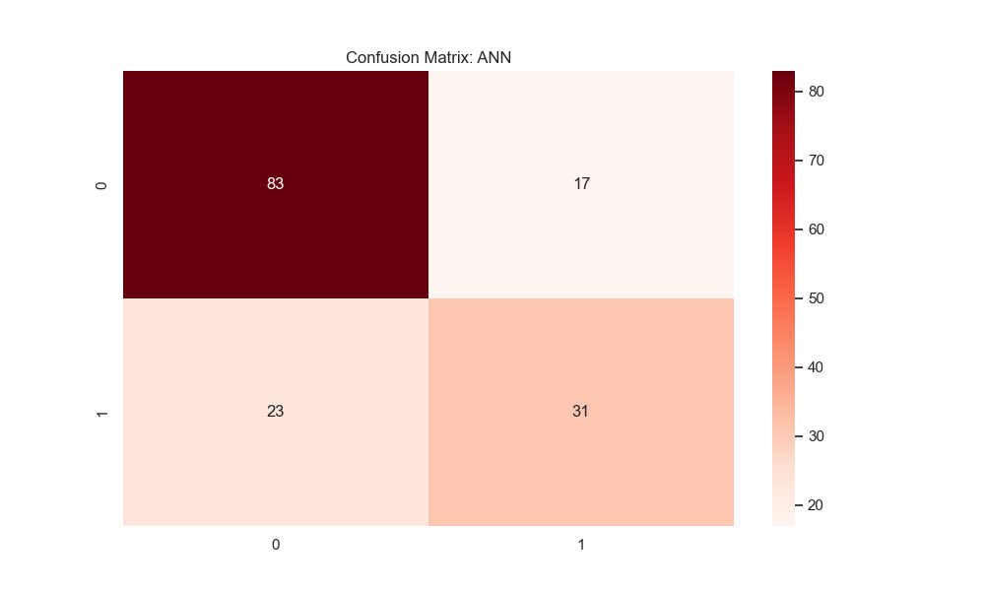
Fig. 17. Confusion Matrix - Artificial Neural Network.
D. Random Forest Feature Importance
Fig. 18 shows the feature importance rankings derived from the Random Forest model, corroborating the SHAP analysis results.

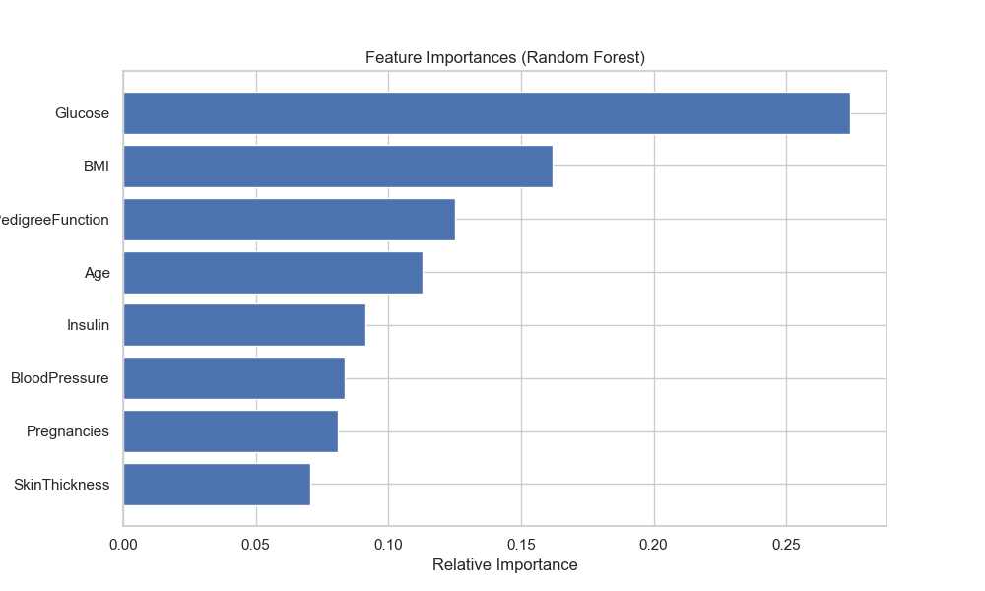
Fig. 18. Random Forest Feature Importance Rankings.
IX. EXPLAINABLE AI USING SHAP
To improve transparency, SHAP (SHapley Additive Explanations) was integrated into the prediction system using the Random Forest model. SHAP values are derived from cooperative game theory and assign each feature a contribution value for a particular prediction.
A. SHAP Feature Importance
Table V presents the global SHAP feature importance rankings based on mean absolute SHAP values computed across all test samples.

TABLE V
SHAP Global Feature Importance
Feature | Mean |SHAP Value|
Glucose | 0.1343
BMI | 0.0757
Age | 0.0546
DiabetesPedigreeFunction | 0.0410
Insulin | 0.0347
Pregnancies | 0.0275
SkinThickness | 0.0203
BloodPressure | 0.0144

B. SHAP Summary Plots
Fig. 19 shows the SHAP summary bar plot providing global feature importance rankings. Fig. 20 presents the beeswarm plot illustrating both feature importance magnitude and directional impact on predictions.

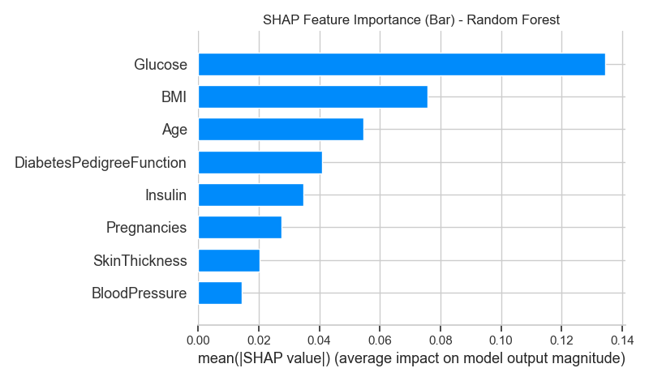
Fig. 19. SHAP Summary Bar Plot - Global Feature Importance.

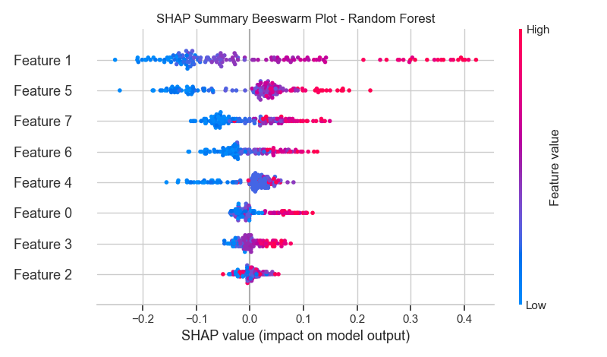
Fig. 20. SHAP Beeswarm Plot - Feature Impact Distribution.
C. SHAP Dependence Plots
Figs. 21-23 show SHAP dependence plots for the top three most influential features: Glucose, BMI, and Age, illustrating their marginal contributions to model predictions.

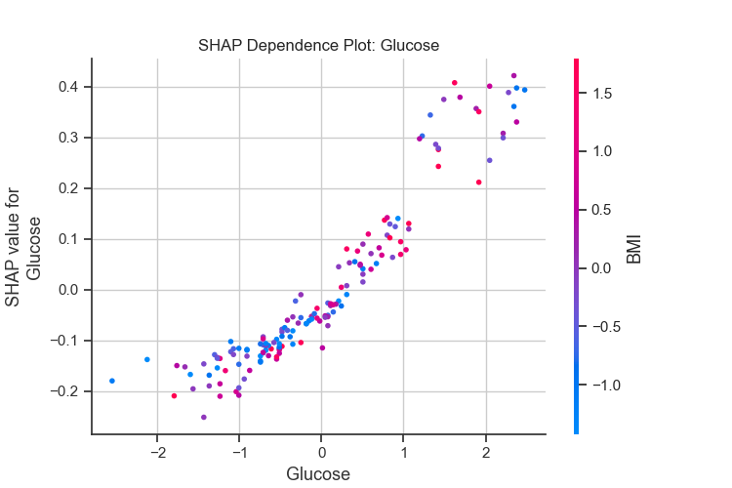
Fig. 21. SHAP Dependence Plot - Glucose.

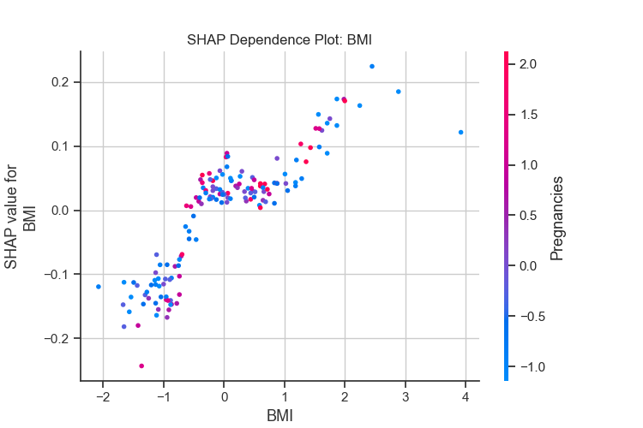
Fig. 22. SHAP Dependence Plot - BMI.

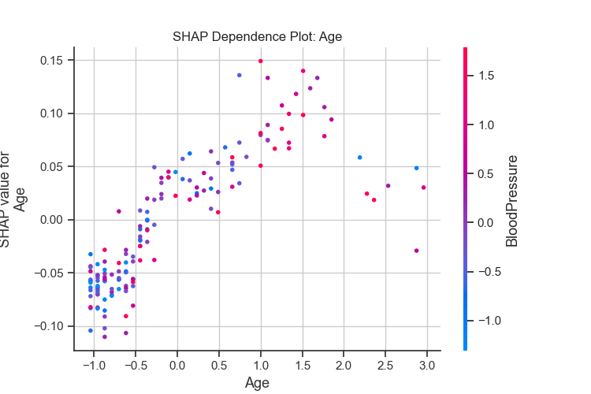
Fig. 23. SHAP Dependence Plot - Age.
D. SHAP Waterfall Plot
Fig. 24 shows the SHAP waterfall plot for an individual prediction, decomposing the model output into contributions from each feature starting from the expected base value.

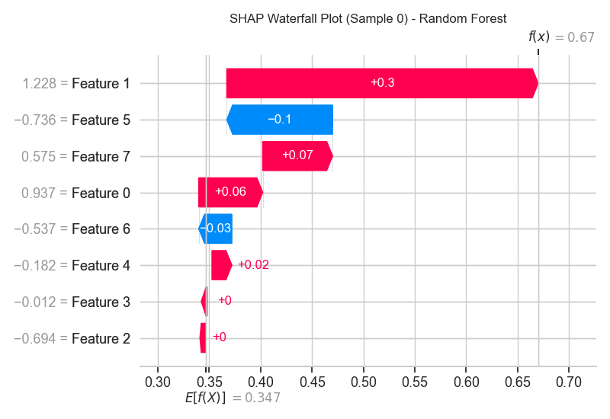
Fig. 24. SHAP Waterfall Plot for Individual Prediction.
E. SHAP Interpretation
SHAP analysis demonstrates that Glucose had the strongest impact on diabetes prediction with a mean |SHAP value| of 0.1343. Higher glucose levels significantly increased the predicted probability of diabetes. BMI (0.0757) and Age (0.0546) were identified as the second and third most influential features respectively. DiabetesPedigreeFunction and Insulin also contributed meaningfully, while BloodPressure showed the weakest individual influence. These findings are consistent with established clinical knowledge about Type 2 diabetes risk factors.
X. DISCUSSION
The comparative analysis demonstrates that ensemble and deep learning models outperform simpler classification techniques for diabetes prediction. The ANN model achieved the best ROC-AUC score of 82.04%, indicating strong capability in learning complex nonlinear feature interactions. However, Random Forest achieved the highest accuracy (77.92%) and competitive AUC (81.91%) while offering superior interpretability through inherent feature importance measures.
Decision Tree showed relatively lower performance across all metrics, attributable to its susceptibility to overfitting on the training data despite the use of cross-validation. Logistic Regression and SVM demonstrated comparable ROC-AUC scores (~81%), suggesting that linear decision boundaries captured a significant portion of the discriminative information.
The cross-validation accuracy results further confirm model generalization. Logistic Regression achieved the highest CV accuracy of 77.22%, suggesting that the linear model generalizes more consistently, while the ANN was not included in the CV analysis due to computational constraints.
The integration of SHAP explainability significantly improved system transparency by providing feature-level contributions toward individual and aggregate predictions. The consistency between SHAP rankings and clinical domain knowledge (Glucose as the primary diabetes indicator) validates both the model and the explainability framework. This alignment is critical for building clinician trust in AI-based diagnostic systems.
XI. CONCLUSION
This study successfully developed a comprehensive diabetes prediction system using Machine Learning, Deep Learning, and Explainable Artificial Intelligence techniques. Six predictive models were implemented and rigorously evaluated using five performance metrics on the Pima Indians Diabetes Dataset.
Experimental results demonstrated that the Artificial Neural Network achieved the highest ROC-AUC score of 82.04%, while Random Forest provided the best accuracy of 77.92% with strong interpretability. The integration of SHAP explainability improved transparency by quantifying feature-level contributions, with Glucose, BMI, and Age consistently identified as the most influential predictors.
The proposed system demonstrates the effectiveness of combining predictive analytics with Explainable AI for healthcare applications, offering a pathway toward trustworthy clinical decision support systems.
XII. FUTURE WORK
Future research directions include: (1) applying the framework to larger and more diverse healthcare datasets to improve generalizability; (2) incorporating additional clinical features such as HbA1c levels; (3) deploying the model as a web-based clinical decision support application; (4) integrating real-time patient monitoring capabilities; (5) exploring advanced deep learning architectures including attention mechanisms and transformer-based models; and (6) comparing additional XAI techniques such as LIME and Integrated Gradients.
REFERENCES
[1] International Diabetes Federation, "IDF Diabetes Atlas," 10th ed., Brussels, Belgium: International Diabetes Federation, 2021.
[2] K. Kavakiotis, O. Tsave, A. Salifoglou, N. Maglaveras, I. Vlahavas, and I. Chouvarda, "Machine learning and data mining methods in diabetes research," Computational and Structural Biotechnology Journal, vol. 15, pp. 104–116, 2017.
[3] A. Acharya and H. Joshi, "Prediction of diabetes using classification algorithms," Procedia Computer Science, vol. 132, pp. 1578–1585, 2018.
[4] S. M. Lundberg and S.-I. Lee, "A unified approach to interpreting model predictions," in Advances in Neural Information Processing Systems, 2017, vol. 30.
[5] T. Hastie, R. Tibshirani, and J. Friedman, The Elements of Statistical Learning, 2nd ed. New York, NY: Springer, 2009.
[6] L. Breiman, J. Friedman, C. Stone, and R. Olshen, Classification and Regression Trees. Belmont, CA: Wadsworth, 1984.
[7] L. Breiman, "Random forests," Machine Learning, vol. 45, no. 1, pp. 5–32, 2001.
[8] C. Cortes and V. Vapnik, "Support-vector networks," Machine Learning, vol. 20, no. 3, pp. 273–297, 1995.
[9] I. Goodfellow, Y. Bengio, and A. Courville, Deep Learning. Cambridge, MA: MIT Press, 2016.
[10] S. M. Lundberg et al., "From local explanations to global understanding with explainable AI for trees," Nature Machine Intelligence, vol. 2, no. 1, pp. 56–67, 2020.

